MISSISSAUGA DOLPHINS CRICKET ASSOCIATION

(MDCA)

ANNUAL GENERAL MEETING MINUTES

February 15TH, 2024

Opening

Welcome to our annual general meeting.

Quorum
I would like to establish quorum; the club has 509 members. As per our constitution, a 10% attendance of all members is required for quorum. 63 members are required to reach quorum. All members have one vote each.

112 members have logged in virtually- Quorum achieved.

Approval of Agenda

2023’24 AGM AGENDA
Quorum

Approval of Agenda

Opening and Welcome

Treasurer’s Report

Sponsorship & Fundraising

Confirmation of actions taken by the board

Affiliation Progress with the City of Mississauga

Questions from the membership

Adjournment

Can we have a Motion to approve the Agenda?
1st: Adeel Ahmed
2nd: Wajahat Faizan
Opposed: None
Abstaining: None
Motioned Passed

Opening and Welcome

Welcome to our 2023 AGM, thank you to those attending in person and also those logged in virtually to get the insights on what has happened this past year with the organization. We as a board have been able to ensure all the costs to run operations were covered and all members enjoyed their time during our programs.

This season yet again was busier than our last for the organization and its members. With registration of serval new teams and members, we can only see things move upwards.

Treasurer’s Report
It has been a great year for us with the sponsorships, grants and membership. Club was able to get a lot of the funds allotted for the growth.
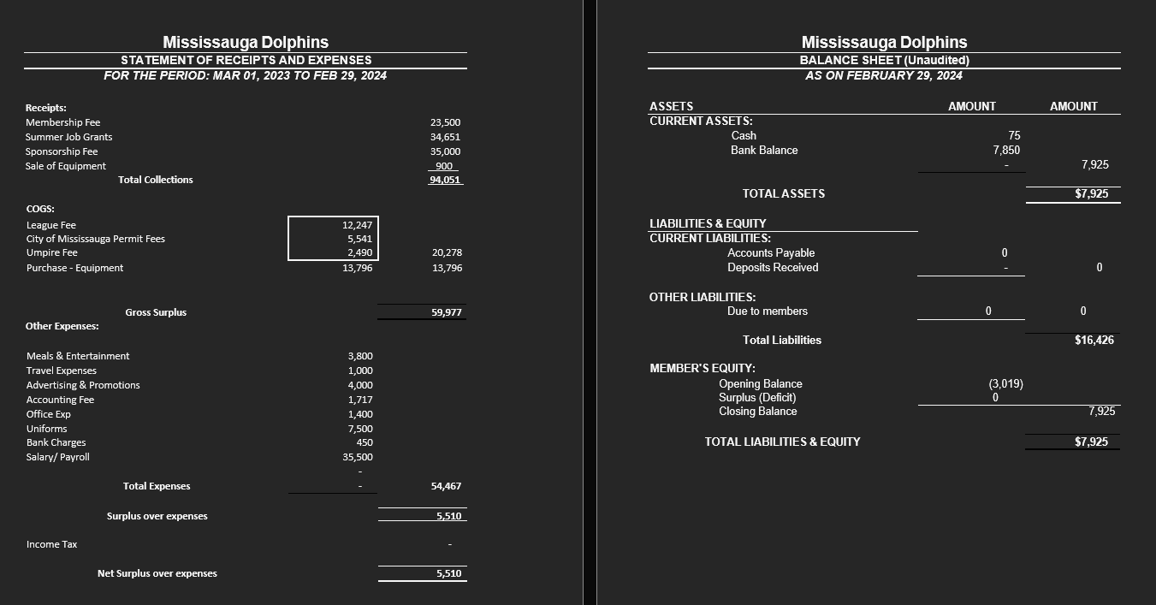

Sponsorship & Fundraising

Superasia.ca & THFG.ca have again done great things for our community. KK Travels, SaveMax, and Akal Opticals showed great support as well.

Confirmation of actions taken by the board

This concludes the reports for the year 2023-24.

Can we have a motion to approve the actions taken by the board?
1st : Ameer Hamza
2nd : Qaiser Choudary
Opposed? None
Abstained? None

Motion carried.

I would like to thank all Board Members for their hard work and continuous support of this club. All board members are volunteers and they take time away from their jobs, families’ and their personal time to serve on this board and ensure this club’s function.

Board Elections Nominees:

Fawaz Al-Aziz, Fayez Al-Aziz, and Umair Ali were elected as new board members.

Questions from the membership

Any questions or comments from the members?

Adjournment

Thank you all for attending this very important meeting.

